Incentive Tours/ Leisure Holidays

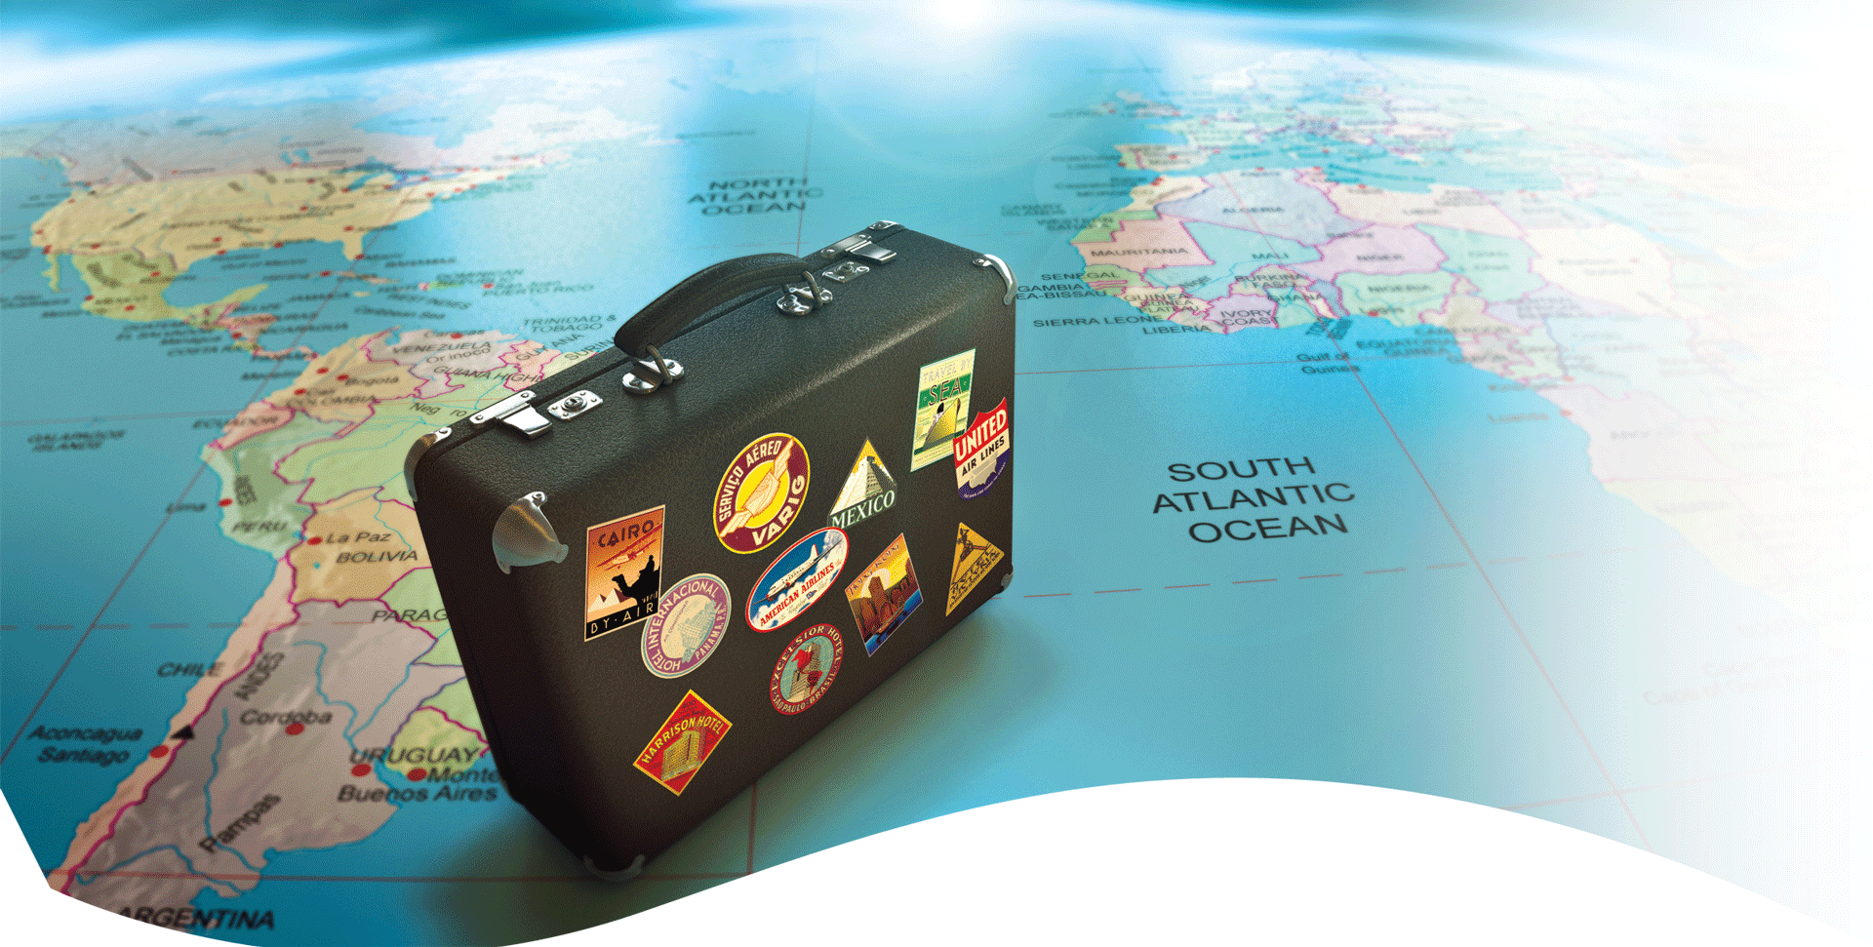
We offer lucrative incentive tours and leisure holiday service for our clients under best competitive rates. Catering to the spectrum of holidays, national and international, we document the tour resource and offer the same to our clients. Time 2 Journey offers exciting destinations to its clients. If you represent a corporate company and looking for incentive tours for employees, then we have innovative ways to reward them with appealing deals.
We offer customized travel solutions for both local and international to clients including government, corporate and individual travellers. Our customized service includes:
- Itinerary Planning
- Incentive Tours
- Airline Reservations
- Hotel Reservation
- Meeting, Conferences & Exhibition
- Group Package
- Car Rentals
Time 2 Journey ensures that travellers have a good time travelling to their destination under professional service like us. If you are looking forward to plan for incentive or leisure holiday, then do contact us for the assistance.

